**Would you like to play a**

**musical instrument?**

**Come along to one our open mornings and find out more about East Glasgow Music School!**

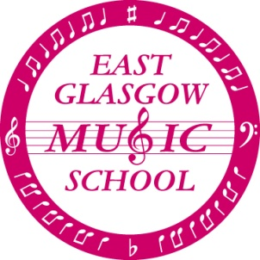

**We offer lessons for primary school children on the following instruments:**

**Violin Cello Flute Piano Oboe**

**Viola Recorder Clarinet Trumpet**

**Open mornings are on Saturday 8th and Saturday 15th September 2018 from 10am-11am in Eastbank Primary School. Children will have an opportunity to try out instruments and meet the tutors.**

**In addition, each child who learns an instrument is automatically a member of our choir, and as children progress on their instrument they will be able to join our orchestra or recorder ensemble.**

**East Glasgow Music School runs on Saturday mornings during term time.**

C:\Documents and Settings\Gillian\Local Settings\Temporary Internet Files\Content.IE5\BB9XIZA7\MC900078766[1].wmf

**Please see our website for further information** [**www.eastglasgowmusicschool.org.uk**](http://www.eastglasgowmusicschool.org.uk)

**We look forward to seeing you soon!**

***East Glasgow Music School is a Scottish charity SC027391***